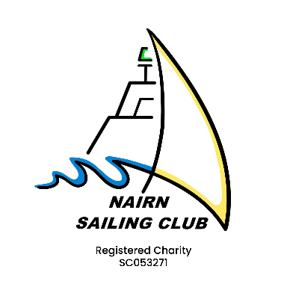
Nairn Sailing Club
Schedule of Fees – January 2025

Annual memberships
Family membership | £100 | 2 adults and any children under 18
Single membership | £80
Intermediate | £25 | Age 18 to 22 or in full time education or a student
Out of Port membership | £25 | Total family cost, outside 50 mile radius or on the north side of the Moray Firth
Friend/Friends of NSC | £25 | At the discretion of the Board
Junior membership | £20 | Age 13 to 17
Under 12’s | £20 | Per child, £20 per adult (to allow cover by club insurance). Under 12’s must be supervised by an adult in any club activity

Participation charges
- Club dinghy use - £25 annual payment per participant using a club dinghy to cover insurance and maintenance. Please include this in your membership payment.
- Race entrance fees (cruisers) - a fee of £5 per race is payable by all competing boats at the pre-race briefing.
Clubhouse key charge
- £5 per key.
Yard and storage fees
Boat space | £10.00 per metre for the 1st 2 x 6-month periods or part thereof. This will rise by £10.00 per metre every 6 months thereafter. | Multi-hulls to pay the equivalent per hull.
Empty cradles and trailers | £20 per 6-month period or part thereof. | Cradles and trailers must be colour coded and clearly marked with the boat or owner’s name.
Dismantled cradles | £0 If dismantled and neatly stored.
Dinghies, canoes, paddleboards, kayaks etc | £20.00 for each 6-month period or part thereof. | Priority will be given to club owned craft.

All craft stored must have a minimum third-party insurance with a limit of liability of at least £3,000,000. Please refer to the Yard Rules as set out in the club handbook.

Affiliated club memberships
Memberships for affiliated clubs and organisations will be calculated per membership and will be calculated on number of members, facilities used, etc.
Hire costs for club facilities
Room | All day hire 9-5 | Half day /evening
Main Hall (upstairs) | £100 | £65
Committee Room (downstairs) | £50 | £35
Kitchen | £20 | £20
Event licence | A £10 special licence application may be required if the bar is to be open outside normal hours

